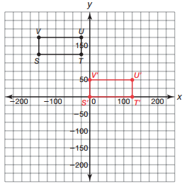
Review – Chapter 14
- Analyze quadrilateral STUV.
- Identify quadrilateral STUV. Explain your reasoning.
I can determine the length of each side by counting.
S’T’ = 125 units; T’U’ = 50 units; U’V’ = 125 units; S’V’ = 50 units
The opposite sides are congruent, and each vertex is a right angle, so STUV is a rectangle.

- Explain how you can transform quadrilateral STUV so that point S’ is located at the origin. Then graph quadrilateral S’T’U’V’ on the coordinate grid and list its coordinates.

To transform rectangle STUV so that point S is on the origin, I must perform two translations. I must translate rectangle STUV down 125 units and 150 units to the right. The coordinates of rectangle S’T’U’V’ are S’(0, 0), T’(125, 0), U’(125, 50), and V’(0, 50).

- Calculate the perimeter of quadrilateral STUV.
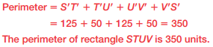

- Calculate the area of quadrilateral STUV.
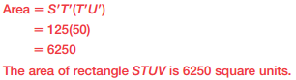

- Analyze triangle ABC.
- Identify the triangle by its angles by finding the slopes of the sides.
Slope of AB: $\frac{2}{3}$ Slope of BC: ​ $-\frac{1}{2}$ Slope of AB: ​0 ​
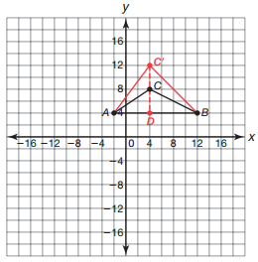
Triangle ABC is not a right triangle because none of the slopes are not negative reciprocals. Triangle ABC is an obtuse triangle.

- Calculate the area of triangle ABC.
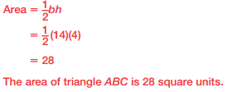

- Double the area of triangle ABC by manipulating point C to create triangle ABC’. Determine the location of point C’.
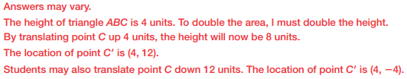

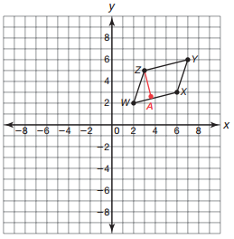
- Analyze parallelogram WXYZ.
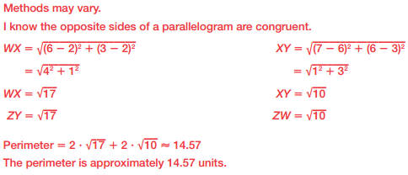
- Determine the perimeter of parallelogram WXYZ.

- Determine the area of parallelogram WXYZ. Show your work or explain your reasoning.
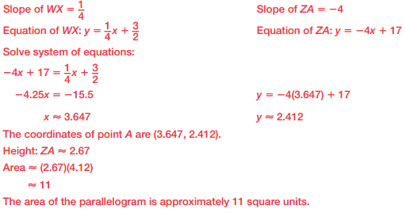

- Analyze the figure shown.
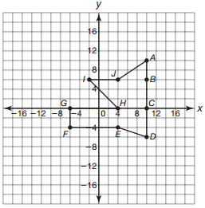
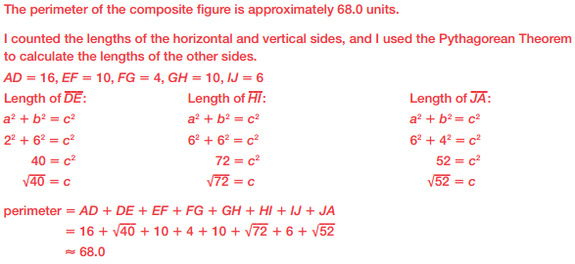
- Determine the perimeter of the composite figure. Round to the nearest tenth.

- Determine the area of the composite figure. Round to the nearest tenth.
