Review – Chapter 14
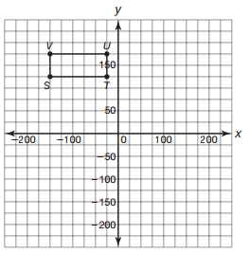
- Analyze quadrilateral STUV.
- Identify quadrilateral STUV. Explain your reasoning.

- Explain how you can transform quadrilateral STUV so that point S’ is located at the origin. Then graph quadrilateral S’T’U’V’ on the coordinate grid and list its coordinates.

- Calculate the perimeter of quadrilateral STUV.

- Calculate the area of quadrilateral STUV.

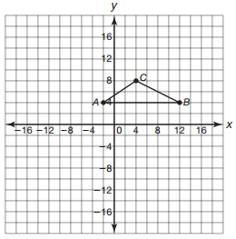
- Analyze triangle ABC.
- Identify the triangle by its angles by finding the slopes of the sides.

- Calculate the area of triangle ABC.

- Double the area of triangle ABC by manipulating point C to create triangle ABC’. Determine the location of point C’.

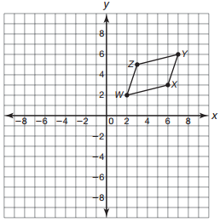
- Analyze parallelogram WXYZ.
- Determine the perimeter of parallelogram WXYZ.

- Determine the area of parallelogram WXYZ. Show your work or explain your reasoning.

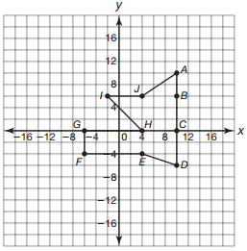
- Analyze the figure shown.
- Determine the perimeter of the composite figure. Round to the nearest tenth.

- Determine the area of the composite figure. Round to the nearest tenth.

