Review – Chapter 12
- Determine the distance between the points (5, 12) and (21, 6).

- Mari draws line segment AB on a coordinate plane. The coordinates of A are (1, 5). The coordinates of B are (-3, 2). She translates the line segment 5 units to the left. She names this line segment A’B’.
- Identify the coordinates of A’ and B’.

- Describe how a horizontal translation changes the coordinates of the endpoints.

- How does the length of the image compare with the length of the pre-image?

- Use construction tools to copy line segment CD.
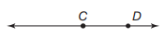

- Calculate the midpoint of a line segment with the endpoints (-2, -1) and (6, 3).

- Mical bisected line segment GH. He labeled the midpoint I. Compare the lengths of $\overline{GI}$ and $\overline{IH}$. Explain your reasoning.

- Cheyanne drew angle JKL on the coordinate plane.

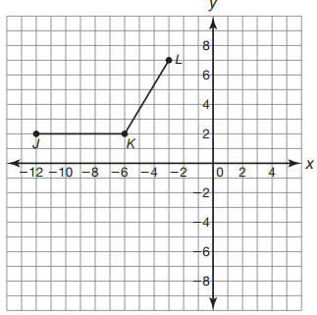

- Translate angle JKL down 7 units. Label the image J’K’L’.
- Describe how a vertical translation changes the coordinates of the angle endpoints.

- Use construction tools to bisect angle JKL.
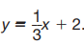
- The equation of line m is

- Write the equation of a line that is parallel to line m. Explain your reasoning.

- Write the equation of a line that is perpendicular to line m. Explain your reasoning.

- Determine the equation of a line that is perpendicular to the line y = - 5x – 8 and passes through the point (- 10, 7)

- Calculate the distance between the line f(x) = 2x – 5 and the point (-6, -2)?

- Use construction tools to construct a square using the given perimeter.

