Review – Chapter 7
- Identify three points that are solutions to each system.
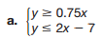

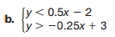

- Write a system of linear inequalities that is represented by the graph.
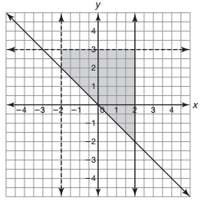
- Tell whether the graph of each inequality would be represented with a dashed line or solid line.

- A company produces CDs and DVDs. There is an expected demand of at least 5000 CDs and 8000 DVDs each day. A total of at most 20,000 items are produced each day. Write a system of linear inequalities to represent the constraints of this situation. Let x represent the number of CDs and y represent the number of DVDs.

- Graph the solution to this system of linear inequalities.

- A company prints flyers and brochures. It takes 2 minutes to print a flyer and 4 minutes to print a brochure. Each flyer uses 12 ounces of ink and each brochure uses 9 ounces of ink. The company has 2 hours available and 360 ounces of ink. The company makes a profit of $1 on each flyer and $2 on each brochure. The company cannot print a negative number of flyers or brochures.
- Let x represent the number of flyers and y represent the number of brochures. Write a system of inequalities to represent the constraints of this problem situation.

- Graph the system of inequalities. Then write and solve an equation to determine how many flyers and brochures the company should print in order to maximize their profit

- Wanda sews small and large gloves. It takes her 45 minutes to sew a small pair of gloves and 120 minutes to sew a large pair of gloves. The costs of producing the gloves are $2 for a small pair and $4 for a large pair. Wanda has 16 hours available to sew gloves. The materials to make the gloves must cost at most $40. The system of linear inequalities represents this situation.
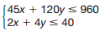
What does the solution (16, 2) represent?

