Review-Chapter 15
- Analyze quadrilateral ABCD.
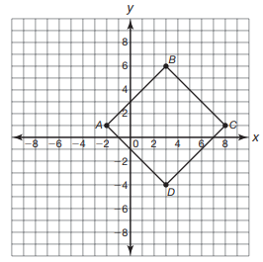

- Determine the length of each side of quadrilateral ABCD.

- Determine the slope of each line segment of quadrilateral ABCD.

- Determine if quadrilateral ABCD can best be described as a trapezoid, a rhombus, a rectangle, or a square. Explain your reasoning.

- Use line segment FG to answer the following questions.
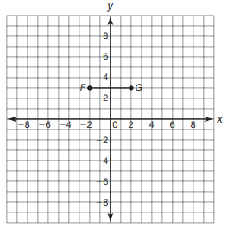
- Determine the location of point H such that triangle FGH is an equilateral triangle.
There are two possible locations for point H. Circle F and circle G, both with radius FG, intersect at two locations. Either point of intersection is a possible location for point H.

- Suppose triangle FGH is a right triangle with right angle G. Determine the location of point H.

- Analyze triangle LMN.
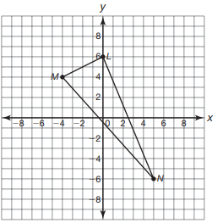
- Determine if triangle LMN is scalene, isosceles, or equilateral. Explain your reasoning.

- Determine if triangle LMN is scalene, isosceles, or equilateral. Explain your reasoning.

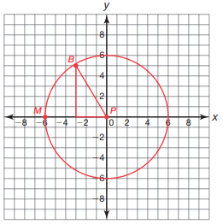
- Circle P has its center at the origin, and contains point M at (-6, 0).

- Draw circle P.
- Determine the length of segment MP. What is this line segment called in reference to circle P?

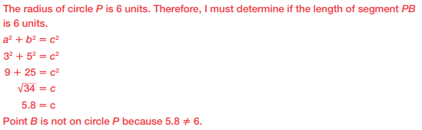
- Plot point B at (-3, 5) on the coordinate plane. Is point B on circle P? Explain your reasoning.

- Circle A has its center at (7, -2) and contains point T (11, 1).
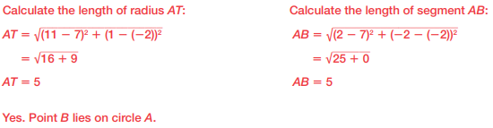
- Determine if point B (2, -2) lies on circle A.

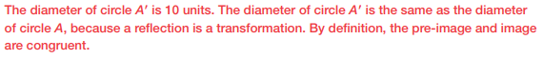
- Suppose circle A is reflected over the y-axis. Determine the diameter of circle A’.

- Determine the center of circle C’.
The center of C’ is (-7, -2).
- Identify the coordinates of the point that lies directly above the center of circle C’.
The point that lies above the center of circle C’ is (-7, 3).

