Review – Chapter 13
- Analyze parallelogram ABCD.
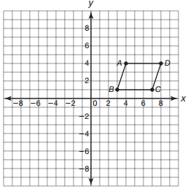
- Rotate parallelogram ABCD about the origin 270° counterclockwise. Graph and label the image as A’B’C’D’. Identify the vertex coordinates of image A’B’C’D’.

- Rotate parallelogram ABCD about the origin 90° counterclockwise. Graph and label the image as A”B”C”D”. Identify the vertex coordinates of image A”B”C”D”.

- Analyze the two triangles shown.
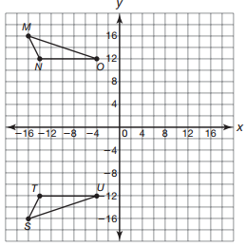

a. Determine the transformation used to create triangle STU.

b. Write a triangle congruence statement for the triangles shown.

- Identify the congruent angles and congruent sides of the triangles.

- Analyze triangle XYZ.
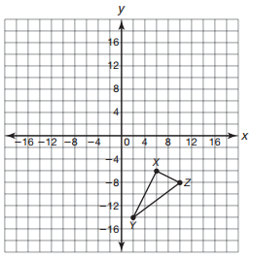

- Calculate the length of each line segment forming the sides of triangle XYZ.

- Translate triangle XYZ up 14 units to form triangle X’Y’Z’. Graph the image. Use the SSS Congruence Theorem to determine if the triangles are congruent. Explain your reasoning.

- Use the SAS Congruence Theorem and a protractor to determine if triangle DEF is congruent to triangle KLM. Explain your reasoning.
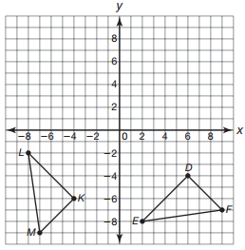

- Analyze the triangles shown.
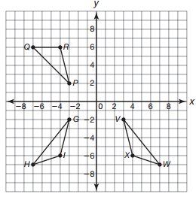

- Use the ASA Congruence Theorem and a protractor to determine if triangle GHI is congruent to triangle PQR.

- Use the AAS Congruence Theorem and a protractor to determine if triangle GHI is congruent to triangle VWX.

