Chapter 6 Evaluation
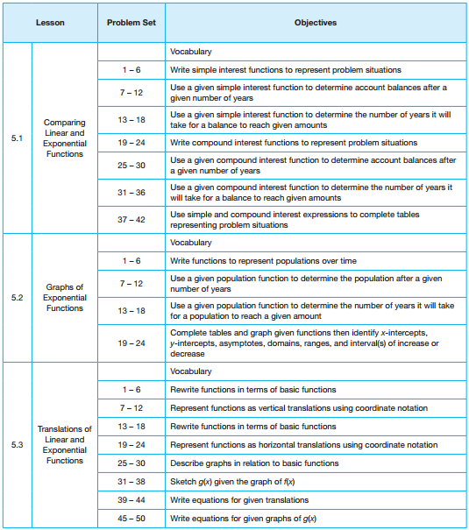
N | A | E | M

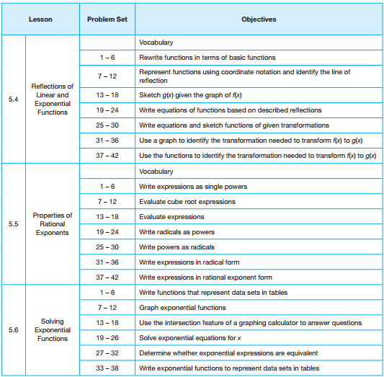
N | A | E | M

N – Novice A – Apprentice E – Expert M - Master

