Chapter 4 Evaluation
N | A | E | M
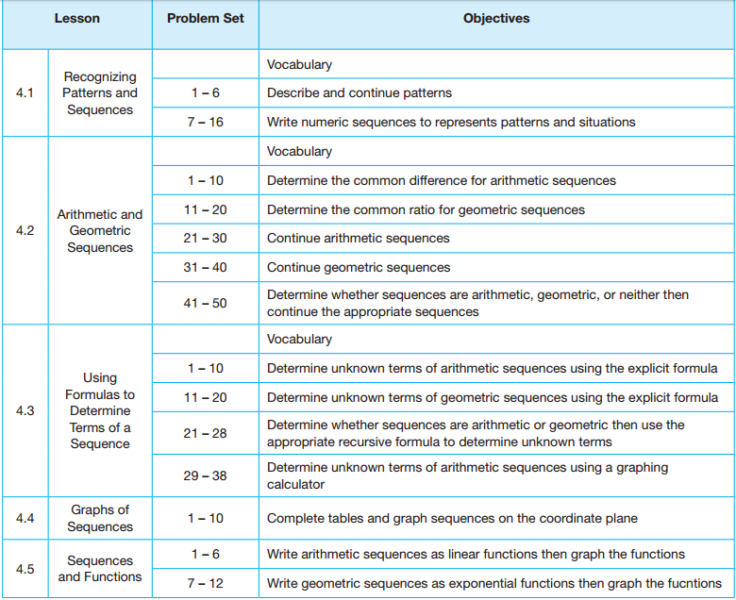
N – Novice A – Apprentice E – Expert M - Master

