Chapter 3 Evaluation
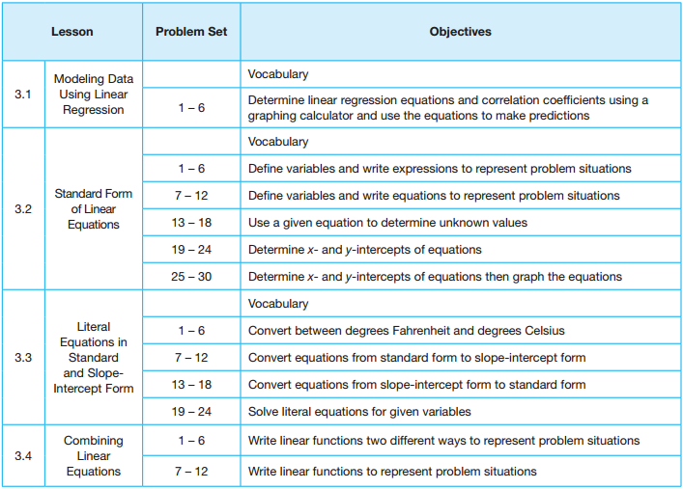
N | A | E | M
N – Novice A – Apprentice E – Expert M - Master

