N | A | E | M
Chapter 12 Evaluation
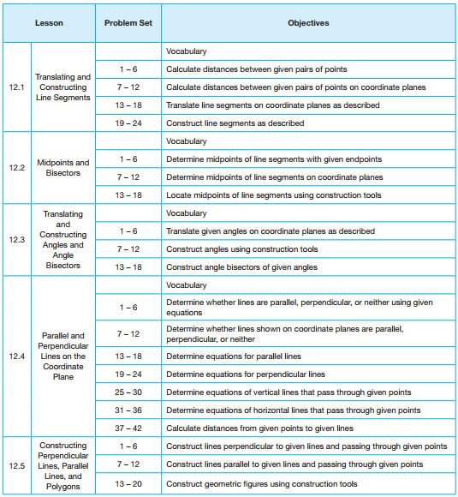

N – Novice A – Apprentice E – Expert M - Master

